

**FEA**

Computational Assignment No. 01

**Instructor:**

Mr. Malik Hassan

**Date:** 18 April 2022

**Submitted by:**

**Waqar Ahmad**

**2018506**

Question: You are required to evaluate the stresses (tension and  
compression) in nine bar truss depicted in Figure 1 through MATLAB  
code. Also, determine the stresses analytically and comment on the error  
if any. Moreover, show the deformed and un-deformed geometry of the  
truss and justify that truss deformation is with in elastic limit.  
While developing a code you may follow following steps:  
• Code accept appropriate data, orientation of element, local and  
global code number and boundary condition details  
• Generate element matrices and transform to global reference frame  
• Perform assembly incorporating boundary conditions  
• Solve for stresses

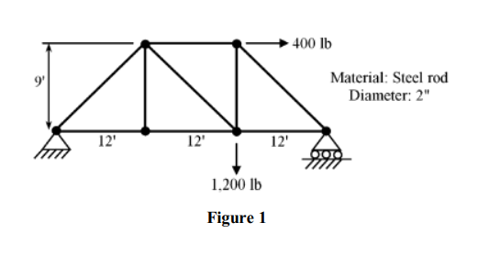

**Code In Matlab:**

% co-ordinates of nodes in x and y(unit inches)

x=12*[0 12 24 36 24 12]';

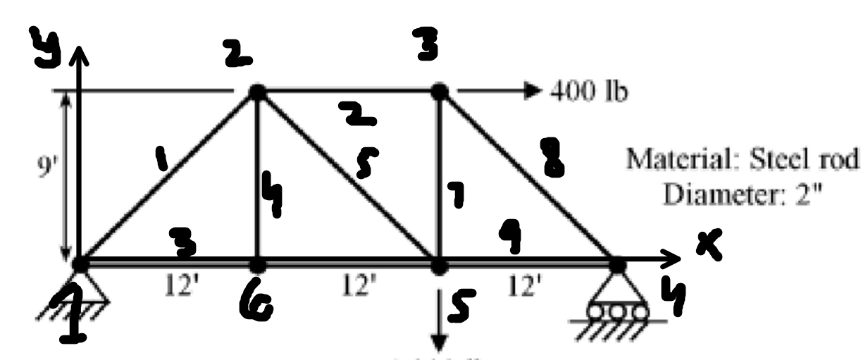

y=12*[0 9 9 0 0 0]';

% There are six nodes

Total_node=6;

% Element and it node combination

Elements=[1 2;2 3;1 6;6 2;2 5;6 5;5 3;3 4;5 4];

E_num=9 %Total number of element

% Area of elements

diameter=2; % diameter

A=(pi/4)*(diameter^2)*ones(E_num,1);

% Young Modulus of element, steel E = 29e6 psi and make it matrice

E=29e6*ones(E_num,1);

**Algorithm for stiffness matrix:**

for i=1:E_num

% Check for element nodes

j=Elements(i,1);

k=Elements(i,2);

%Pythagorean theorem

L(i)=sqrt((x(k)-x(j))^2+(y(k)-y(j))^2);

B{i}=[1/L(i),0,-1/L(i),0];

E1=29e6;

% Transfer function

l(i)=(x(k)-x(j))/L(i);

m(i)=(y(k)-y(j))/L(i);

M=[l(i),m(i);-m(i),l(i)];

Z=[0,0;0,0];

T{i}=[M,Z;Z,M];

% local stiffness matrice 

Local_K{i}=A(i)*T{i}'*B{i}'*E1*B{i}*T{i}*L(i);

end

**Algorithm Global Stiffness Matrix:**

Global_K=0;

for i=1:E_num

%Making the matrice of 12 by 12

% and making zero for each interval

tem_K{i}=zeros(2*Total_node,2*Total_node);

j=Elements(i,1);

k=Elements(i,2);

% Replace the coordinate of local matrice in global

tem_K{i}(2*j-1:2*j,2*j-1:2*j)=local_K{i}(1:2,1:2);

tem_K{i}(2*j-1:2*j,2*k-1:2*k)=local_K{i}(1:2,3:4);

tem_K{i}(2*k-1:2*k,2*k-1:2*k)=local_K{i}(3:4,3:4);

tem_K{i}(2*k-1:2*k,2*j-1:2*j)=local_K{i}(3:4,1:2);

%add all matric

Global_K=Global_K+tem_K{i};

end

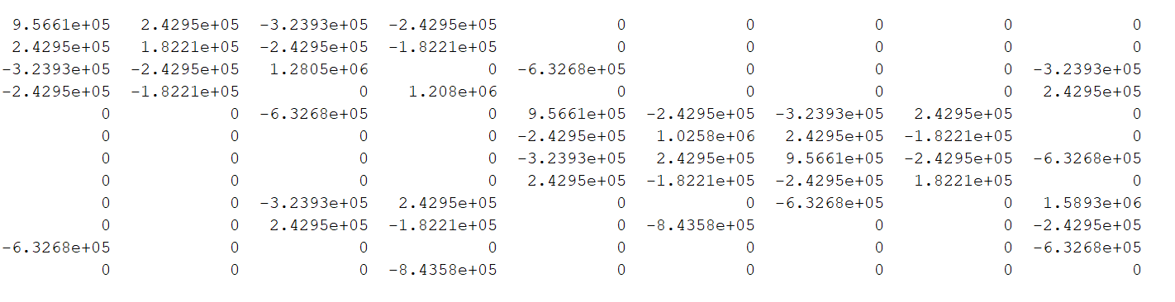 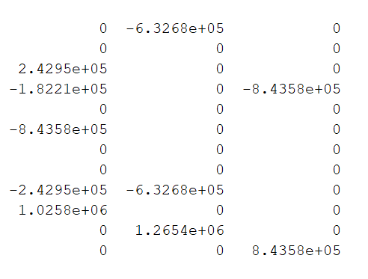

**Force Matrice:**

F=[0 0 0 0 400 0 0 0 0 1500 0 0]';

%consider the reaction force zero which will be resolve latter

**Remove the 1st and 2nd Row and Column:**

node=1

u(2*node-1:2*node)=0

Global_K(2*node-1:2*node,:)=0

Global_K(:,2*node-1:2*node)=0

Global_K(2*node-1,2*node-1)=1

Global_K(2*node,2*node)=1

F(2*node-1:2*node)=0

**Remove the lastst Row and Column:**

node=12

u(2*node)=0

Global_K(2*node,:)=0

Global_K(:,2*node)=0

Global_K(2*node,2*node)=1

F(2*node)=0

**Algorithm for Reduced row echelon form:**

Aug=[Global_K F];

for i=1:1:2*Total_node

for j=i+1:2*Total_node

Aug(j,:)=Aug(j,:)-(Aug(j,i)/Aug(i,i))*Aug(i,:);

end

for j=i-1:-1:1

Aug(j,:)=Aug(j,:)-(Aug(j,i)/Aug(i,i))*Aug(i,:);

end

end

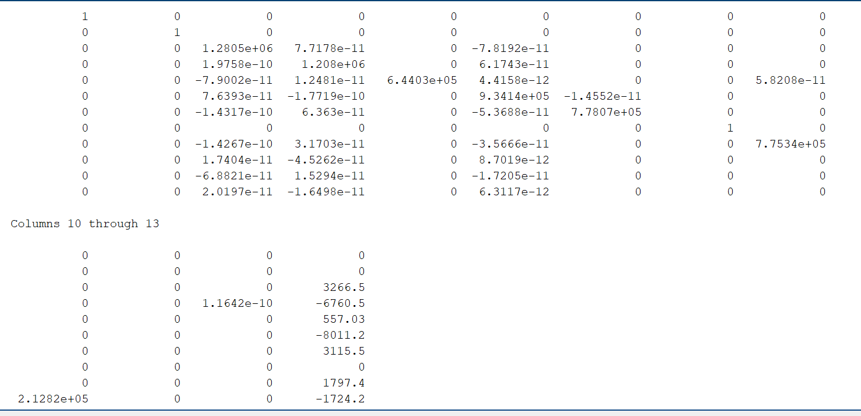

**Divide the force on stiffness which is already reduce:**

depormation=zeros(2*Total_node,1);

for i=1:2*Total_node

depormation(i,1)=Aug(i,2*Total_node+1)/Aug(i,i);

end

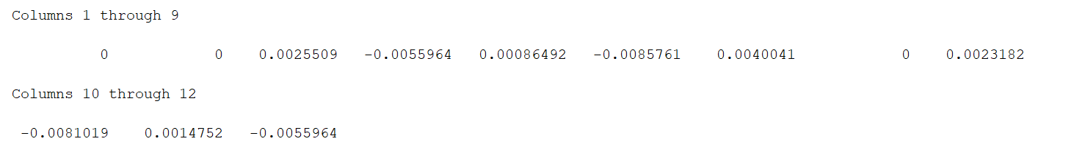

**Finding Support Reactions:**

RF=Global_K*depormation;

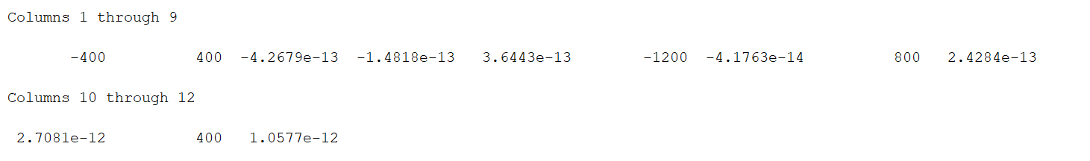

**Algorithm for Strain Calculations:**

strain=zeros(E_num,1);

for i=1:E_num

j=Elements(i,1);

k=Elements(i,2);

a=[l(i) m(i)];

b=[depormation(2*k-1)-depormation(2*j-1);depormation(2*k)-depormation(2*j)];

strain(i)=a*b/L(i);

strain1(i,1)=i;

strain1(i,2)=strain(i);

end

**Algorithm for Stress Calculations:**

Stress=zeros(E_num,1);

for i=1:E_num

Stress(i)=E(i)*strain(i);

stress1(i,1)=i;

stress1(i,2)=Stress(i);

end



**Deformed and Nn-Deformed geometry:**

for i=1:Elements

Afac = max(A);

plot([Elements(ID(i,1),2) Elements(ID(i,2),2)],[Elements(ID(i,1),3) Elements(ID(i,2),3) ],'Color',[.50 .50 .60])

hold on

if fe(i)>0

plot([Elements(ID(i,1),1) Elements(ID(i,2),1)],[Elements(ID(i,1),2) Elements(ID(i,2),2)],'b-.','Linewidth',3)

else

plot([Elements(ID(i,1),1) Elements(ID(i,2),1)],[Elements(ID(i,1),2) Elements(ID(i,2),2)],'b-.','Linewidth',3)

end

title('Deformed and Nn-Deformed geometry')

xlabel('X ')

ylabel('Y ')

hold on

grid on

end

